Please download the application via <https://github.com/miariany/springmvc-json>

Spring Framework 5 Application Demo and Set Up Instruction.

1. Code editor: eclipse IDE 2019-09

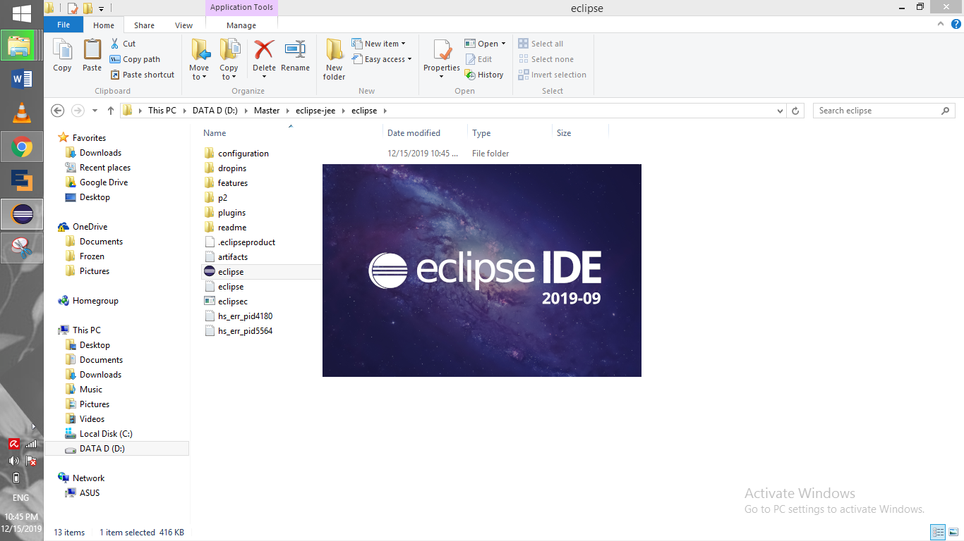

1. Copy “springmvc-json” project to a folder and import the project. Open Eclipse > File > Import > Choose Maven Existing Project

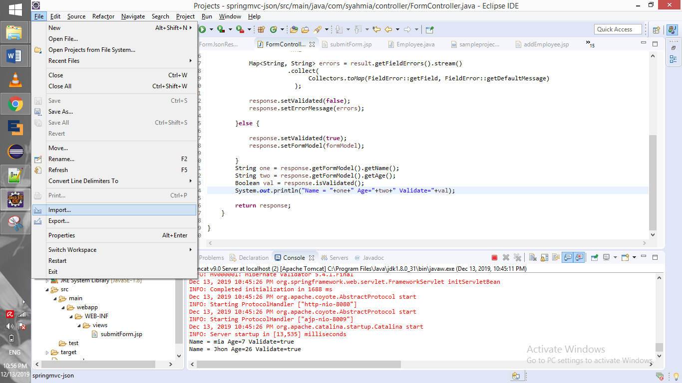

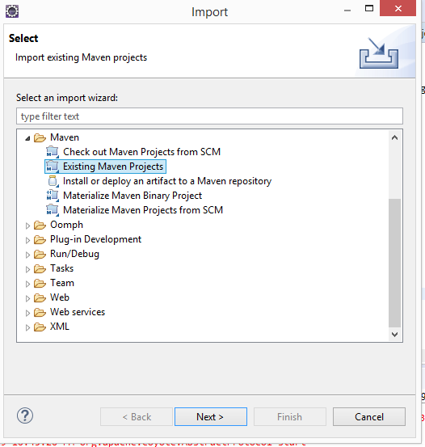

1. After done importing, right click project folder. Update Maven project might be required if still there an error.

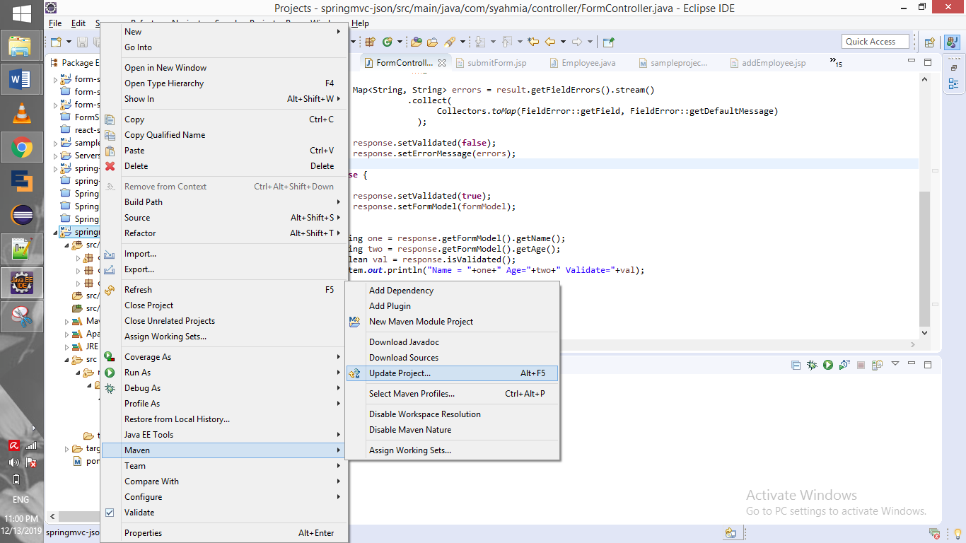

1. To ensure the project able to run. Please make sure the configuration same as below.

Project Facet properties

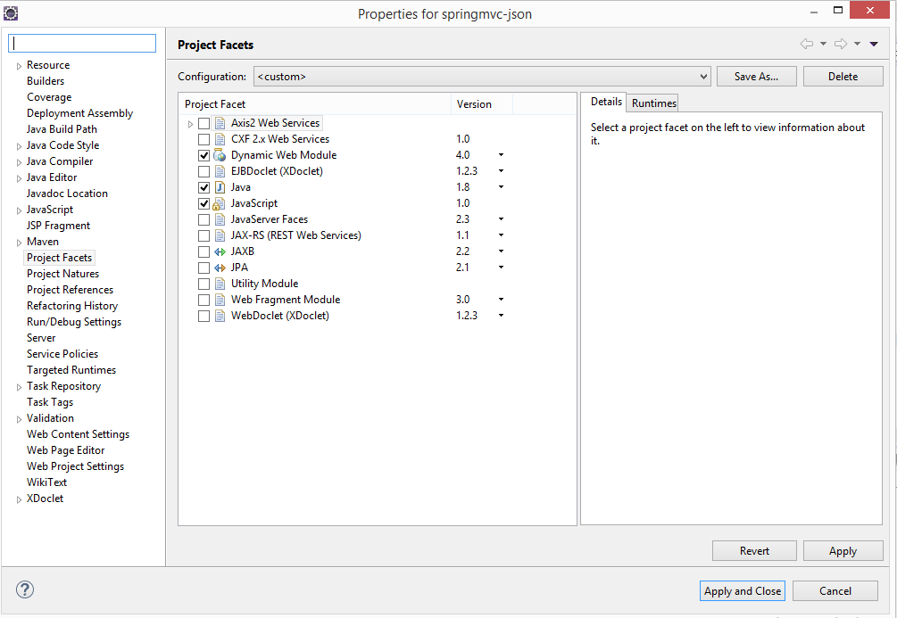

Java Build Path

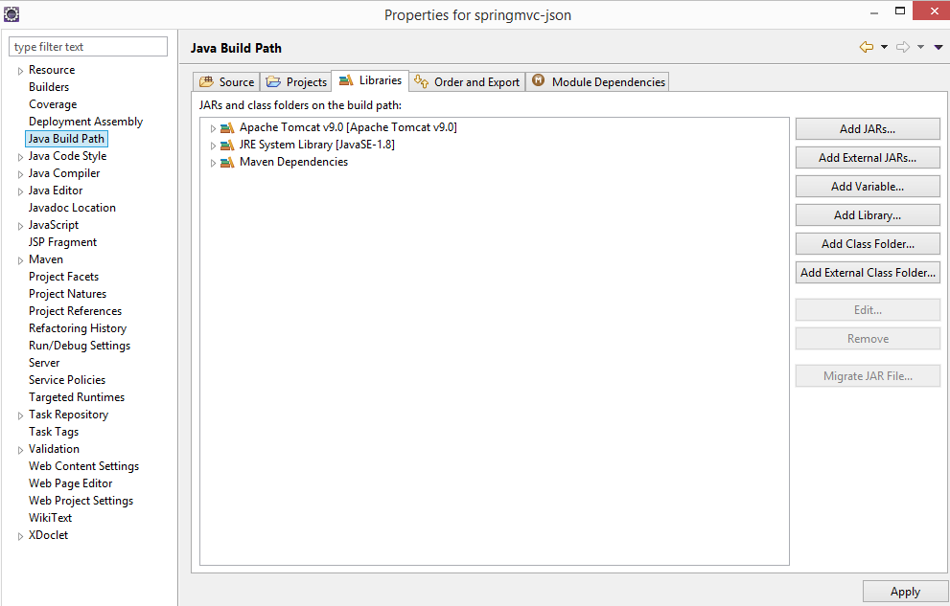

Deployment Assembly

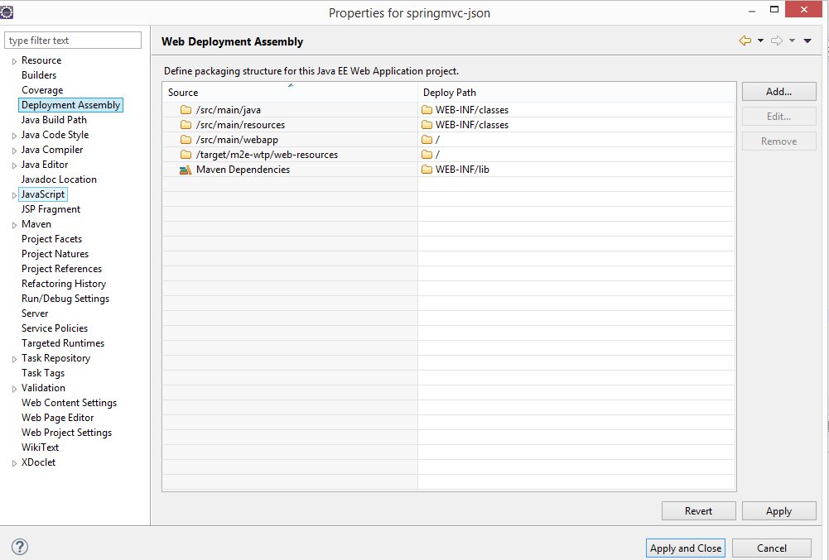

Targeted Runtimes

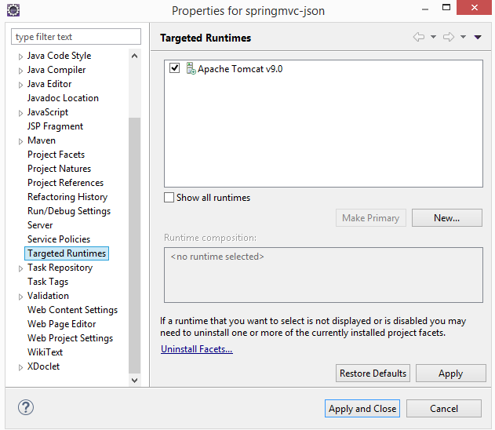

Java Compiler jdk 1.8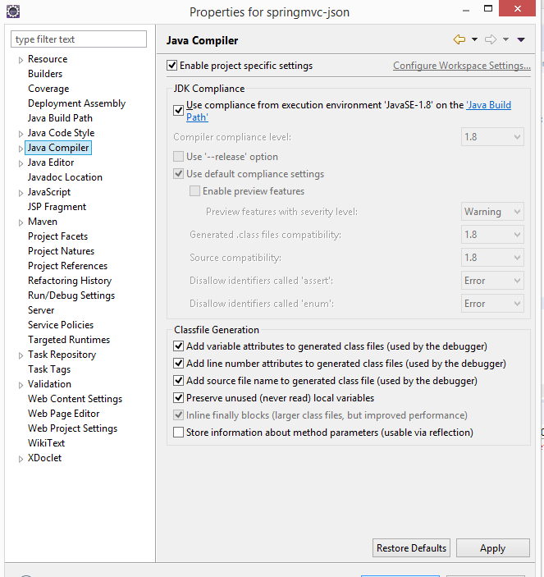

Change Default Browser to Chrome

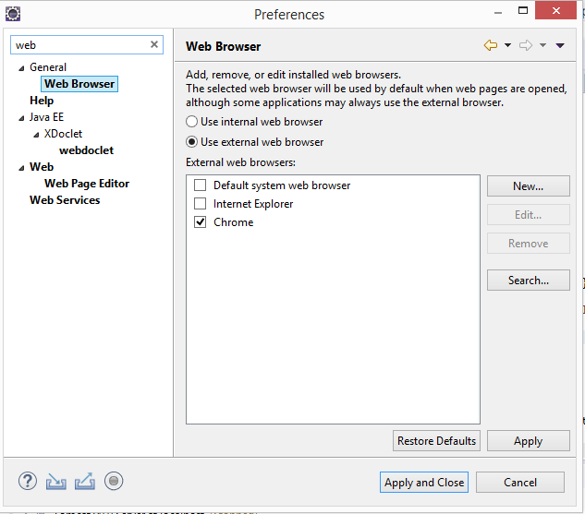

1. Ensure Project Structure as per below.

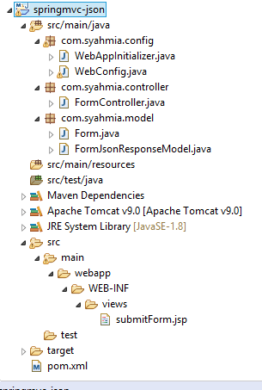

Com.syahmia.config = Custom configuration for spring application.

Com.syahmia.controller = Controller class to do get and post mapping of request and response.

Com.syahmia.model = Model classes.

1. Run project by Server Apache Tomcat 9

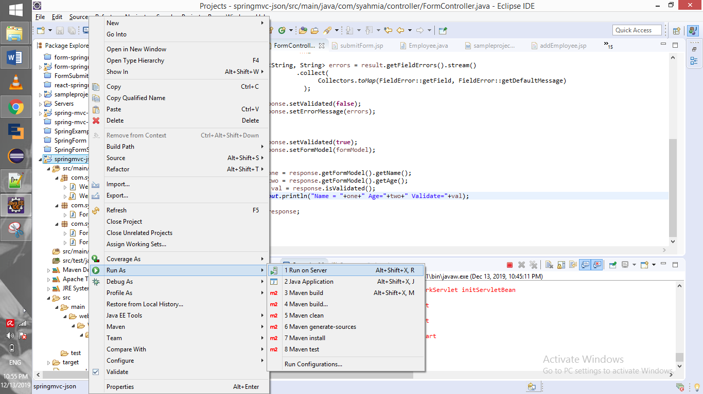

1. After apache tomcat successful run the server. A form will show up in the default browser as below picture.

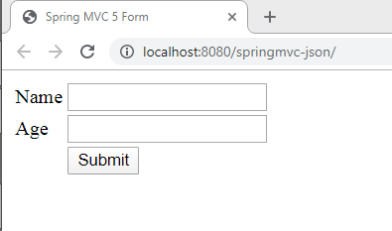

1. Fill up the form. Below is the application demo.

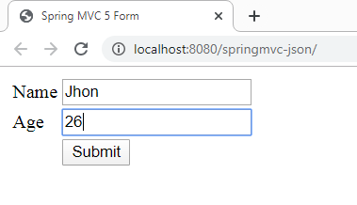

1. Click submit button. Then server will return response processed by JSON below the form.

